CYBERSECURITY TOOLS · WEEKLY LEARNING TRACK
Nmap Reference Documentation
Timing Templates & Performance Tuning

Prepared by Emmanuel Aidoo
Kali Linux · Nmap 7.98
September 21, 2026

Contents
1 Minimum Rate Tuning (--min-rate) 3
2 Aggressive Timing via Zenmap (-T4) 4
3 Insane Timing (-T5) 5
4 Key Takeaways 6

In this module, I looked at how Nmap's speed and reliability trade off against each other — forcing a minimum packet rate, stepping up through the built-in timing templates, and what happens to accuracy at the fastest settings.

1 Minimum Rate Tuning (--min-rate)
--min-rate tells Nmap never to send probe packets slower than the given number per seond, overriding its usual congestion-control pacing. This is useful when you already trust the network can handle it.
● ● ●
$ nmap --min-rate 1000 173.230.138.70
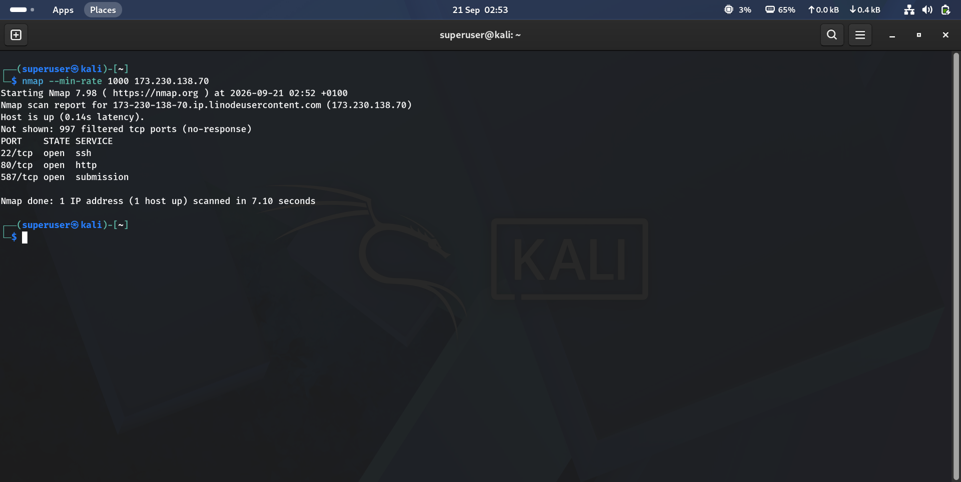
Figure 1 · Forcing a 1000 packets/second minimum send rate against 173.230.138.70
Result summary
Port | State | Service
22/tcp | open | ssh
80/tcp | open | http
587/tcp | open | submission

Observation
997 of 1000 ports filtered, same three ports open as every earlier scan of this host — but the whole thing finished in 7.10 seconds. That's close to the fastest result seen against this target across every module so far, purely from forcing the packet rate rather than changing scan type.

2 Aggressive Timing via Zenmap (-T4)
I used Nmap's official graphical front-end(Zenmap) same scan engine, same output, just a GUI wrapped around the command line. This run used -T4 (“Aggressive”, one step below the fastest template) combined with -sV and -A for full version detection, OS attempts, scripts, and a traceroute.
● ● ●
$ nmap -sV -T4 -A -v 173.230.138.70
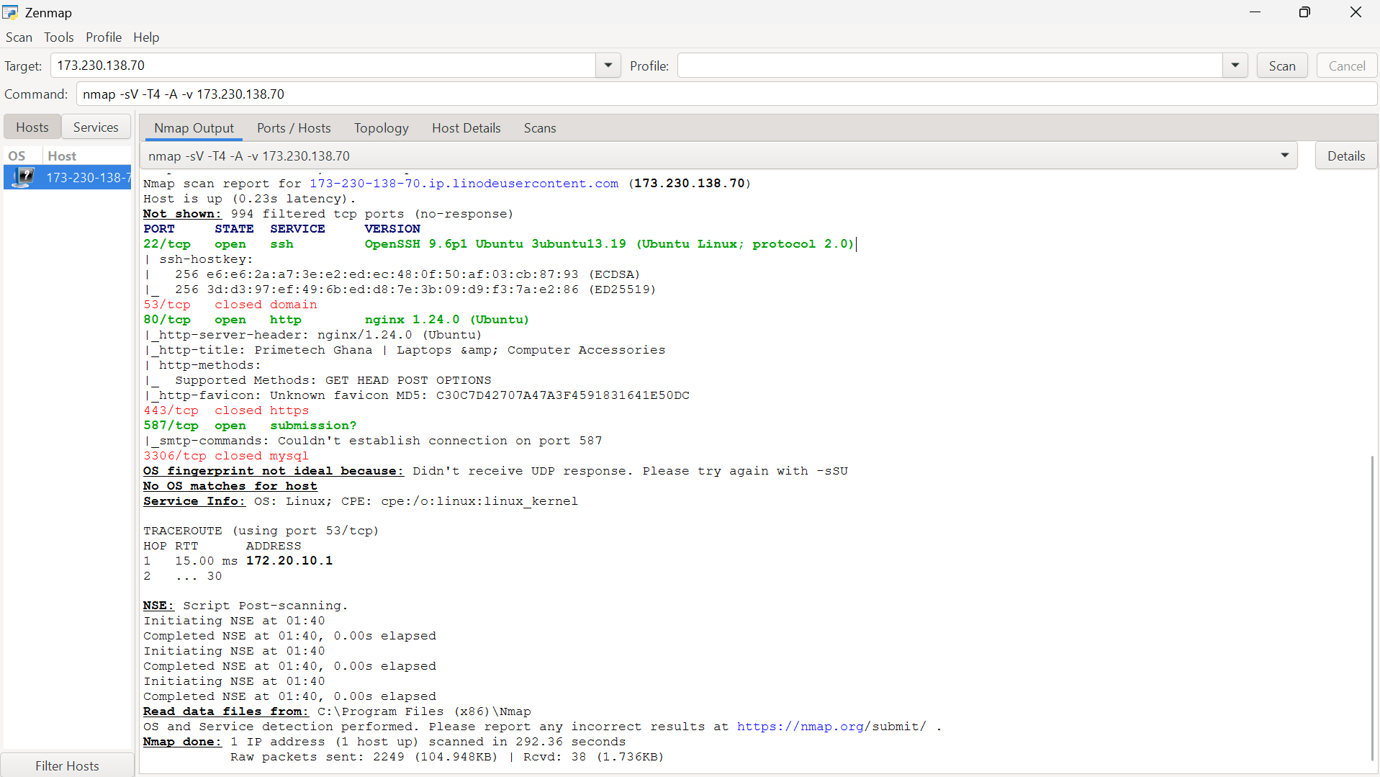
Figure 2 · Zenmap GUI running an intense -T4 scan with full version detection
Result summary
Port | State | Version detected
22/tcp | open | OpenSSH 9.6p1 Ubuntu 3ubuntu13.19 (protocol 2.0)
53/tcp | closed | —
80/tcp | open | nginx 1.24.0 (Ubuntu) — title: Primetech Ghana
443/tcp | closed | —
587/tcp | open | submission? (unconfirmed)
3306/tcp | closed | —

This time the banners came through
Every earlier scan of this host reported ports 22, 80, and 587 as tcpwrapped — open, but with no identifiable service. Here, the exact same ports resolved to real version strings: OpenSSH 9.6p1 and nginx 1.24.0. Nothing about the target changed; what's different is -sV was combined explicitly with -A this time, and Zenmap's default verbosity (-v) ran a fuller probe set. It's a reminder that tcpwrapped isn't necessarily permanent.

3 Insane Timing (-T5)
-T5 is Nmap's fastest and least patient timing template — minimal delays between probes, aggressive parallelism, and short timeouts. It trades reliability for raw speed, and this scan shows exactly what that trade costs.
● ● ●
$ nmap -T5 -A 173.230.138.70
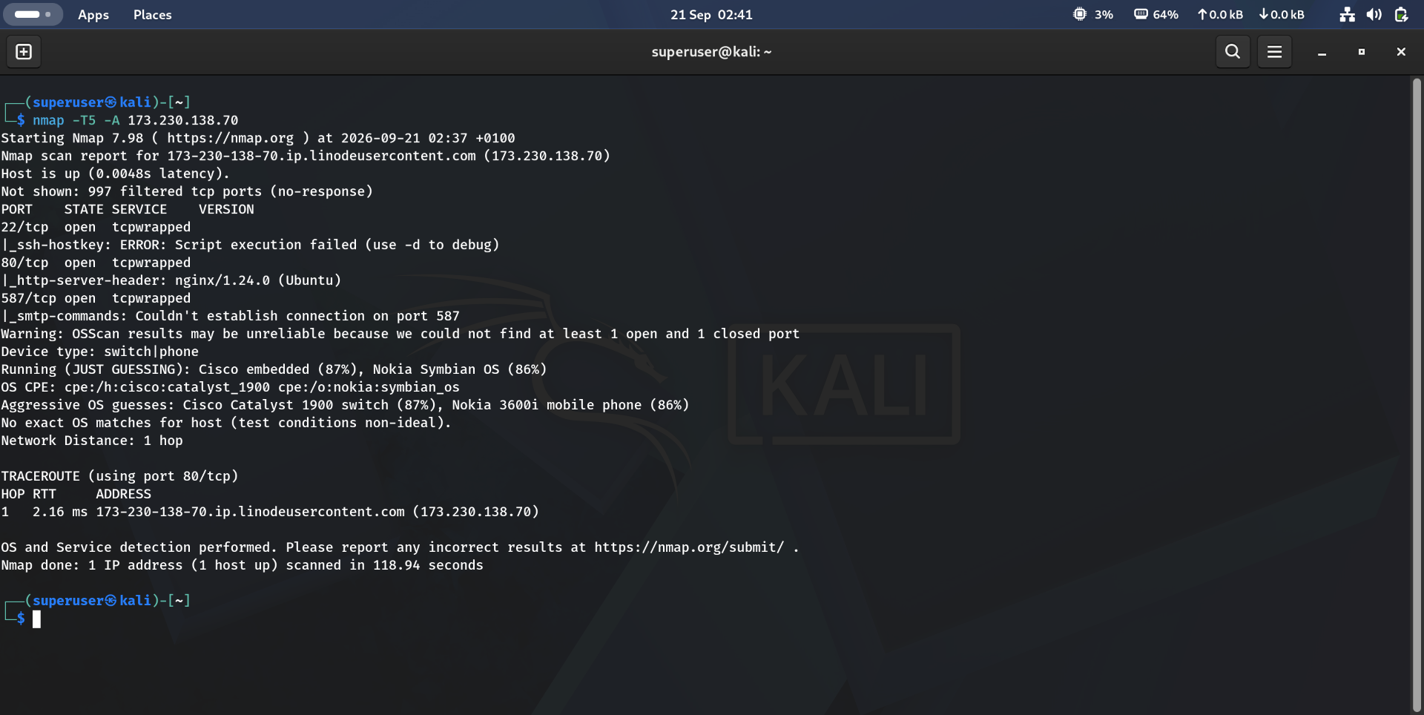
Figure 3 · Insane-speed -T5 scan degrading OS-detection accuracy
What -T5 got wrong
Aspect | Result
Ports | Same 3 open (tcpwrapped) as prior -A runs port scanning itself held up fine
OS detection | “Warning: OSScan results may be unreliable because we could not find at least 1 open and 1 closed port”
OS guesses | Device type: switch|phone — “JUST GUESSING”: Cisco embedded (87%), Nokia Symbian OS (86%); aggressive guesses named a Cisco Catalyst 1900 switch and a Nokia 3600i mobile phone
Scan time | 118.94 seconds — faster than the Zenmap run, but at a real accuracy cost

Speed bought nothing here — and cost accuracy
173.230.138.70 is a Linux server running nginx and OpenSSH, confirmed in Section 2. -T5's guesses — a Cisco switch, a Nokia phone — aren't just wrong, they're a completely different device class, and Nmap itself flagged the result as unreliable rather than presenting it as fact. This is the clearest illustration in the module of the timing/accuracy trade-off: OS fingerprinting depends on precisely-timed responses, and -T5's aggressive pacing didn't leave room to collect them cleanly.

4 Key Takeaways
- --min-rate forces a floor on packet-send speed, letting you trade some of Nmap's built-in congestion caution for a faster scan when you trust the network.
- Zenmap is the same Nmap engine behind a GUI — useful for building and re-running commands visually, not a different scanner.
- tcpwrapped is not a fixed verdict for a host — the same port that stonewalled one scan configuration handed over a full version banner (OpenSSH, nginx) under a different one.
- Timing templates run from -T0 (paranoid) to -T5 (insane) — higher isn't strictly better, since faster pacing can starve accuracy-dependent features like OS fingerprinting.
- When Nmap flags its own OS guess as unreliable, trust that warning over the guess itself — wildly wrong device-class guesses (a Linux web server misread as a Cisco switch) are the direct result of too-aggressive timing, not a genuinely ambiguous host.

